Taiwan Stella Maris Ursuline High School 海星中學
Student: Katherine Tu 涂昭瑜
CEI 2017 Feedback
I always dream that I can represent Taiwan as a delegate to attend an international conference one day, and here we are – Caretakers of the Environment International (CEI 2017) – my very first international conference in my life! This time, I participated in CEI 2017 with classmates and teachers from Stella Maris Ursuline High School (SMHS).
Before the 31st annual conference in July in Salem, Oregon U.S.A., (before the conference) delegates from Taiwan had already met each other for several times. We discussed our presentations of research projects, the performance on the cultural night, and the Taiwanese traditional snacks for the Fun Market. My research project is, Live with Mola Mola – Make a Good Use of Sunfish in Food and Tourism. I started this project since 6 months ago. Because I got considerable amounts of school works to do and I also need to prepare lots of exams, I have to find the balance between these essential works. Fortunately, I managed to go through all difficulties and finish my research project.
After the final exam, it’s time to start my CEI 2017 adventure! The journey started with 10 hours flight to Seattle, WA. The first thing I’m impressed with is the INCREDIBLE sunset glow. It’s so colourful that you won’t imagine if you have never seen it before. Surprisingly, jet leg is not a problem to me. I think I might be born to be a traveler. Next day, I had four hours bus trip to Western Oregon University (WOU). Even though it was a very long driving time, I really enjoyed the journey. During the trip to WOU, I saw Moda Center, which is a stadium for “Trail Blazers” , where Shawn Mendes held a concert there on July 6th. It is a pity that I didn’t have the chance to meet him. Afterwards, I arrived Western Oregon University, and went for registration and check in.
Initially, I was so shy that I didn’t have any courage to chat with other delegates. Believe it or not, when I was walking along the grove, two Russian delegates invited me to join their volleyball game! And this was how I started my CEI adventure. After that, I was motivated to talk to almost every delegate. And then, I realized that most of them are just junior high school students. Unbelievably, their spoken English is so good, even if it’s not their mother tongue. I’m jealous that they don’t have to go to school for eight hours a day except those ones from Hong Kong. One of the Indonesian participants astonished me by his talent reciting every detail of his country. T. During the conference, we had lots of free time to make friends. Once, I played basketball with Turkish, Danish, Japanese, American, Indonesian, and Swedish. That game and the indoor basketball court were marvelous!
On the presentation day, I heard how different groups propagated their methods and opinions about “Following Nature’s Design”. Individually, the most unforgettable project is “Hydroponic” group. Hydroponics is a method of growing plants using mineral nutrient solutions, in water, without soil. The method can be implemented in the places where the soil type is not ideal for the desired crop. In addition, the technique can be used in indoor farming and therefore is very useful in the areas with limited space, especially with the growing need of land for urban development. As a result, hydroponics proves itself to be a good option for large scale food production in the future. Furthermore, there were still lots of projects such as the importance of vitamin D, the differences of benefits between being a vegan and vegetarian and ect….. In fact, I learnt lots of ways and new knowledge to protect our nature resources and maintain the balance between both human beings and environment to reach the win-win situation.
In addition to share our achievements to delegates, we also joined some outdoor activities. For example, we went to the Oregon State University (OSU) to visit the tsunami laboratory. Moreover, we also went to the Mt. Hood National Forest and experienced a youth farm. The most incredible thing is that Independence Day (4th of July). On that day, we watched the parade in the morning, and then walked along Monmouth to the Independence town to enjoy the fireworks. Although it was 5 km far from WOU, I didn’t feel tired at all. This exactly brought me the completely different definitions about National Day. Furthermore, there’s one thing I definitely want to describe in this article. It’s always richly fascinating at every single night. No matter the Fun Market or the Contemporary and Traditional cultural performance, all of these things brought lots of joys to my CEI adventure. We not only promoted Taiwan, but also learnt some languages, cultural differences, experienced the traditional toys, and tasted some odd snacks from other countries.
When I was in America, I felt so comfortable and confident in that environment. To my observation, people in America seldom talk to people ironically. Unbelievably, I didn’t have any gaps between two entirely different countries. Truly, I’m falling in love with this beautiful country.
To sum up, I learnt so many useful skills to protect our Earth during the conference. I realized that although I’m just a 16-year-old teenage student, I am capable of helping others have a preservative consciousness. During the preparing months, I learnt the way to find the balance between school assignments and my project. And, I also realized the importance of time-management. Now, I’m going to tell you that attending CEI 2017 is the most valuable conference I ever had.
In conclusion, if we can be confident to ourselves, then nothing will be the obstacles to resist our goals. Last but not least, I’m proud to say that I’m one of the “CARETAKERS” now.
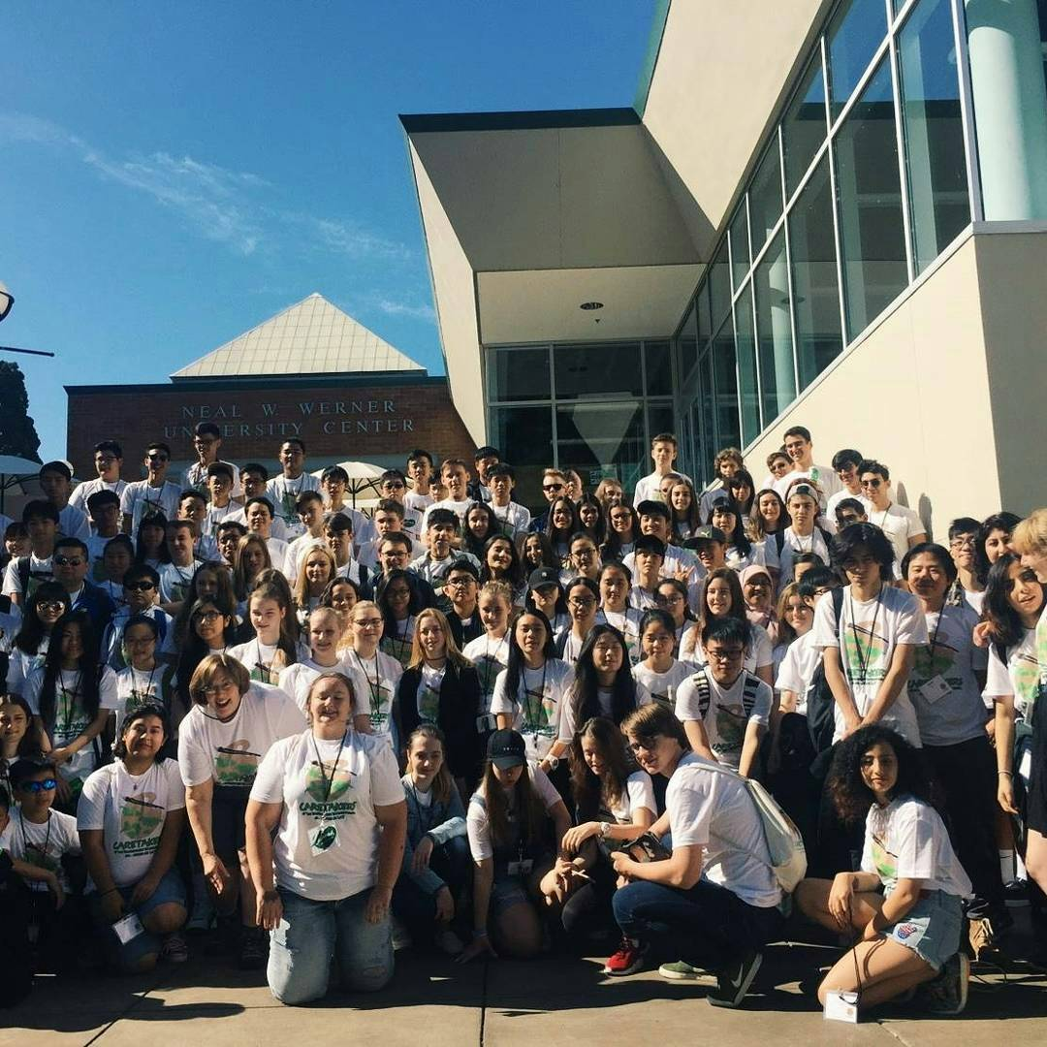
This is the picture of all delegates in 31st annual CEI conference.

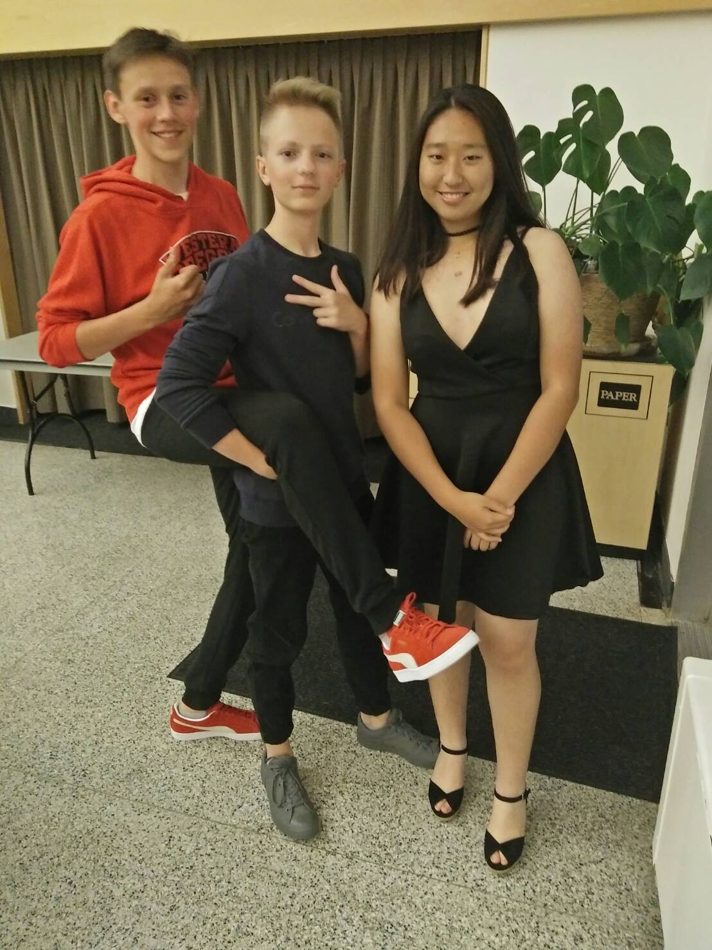
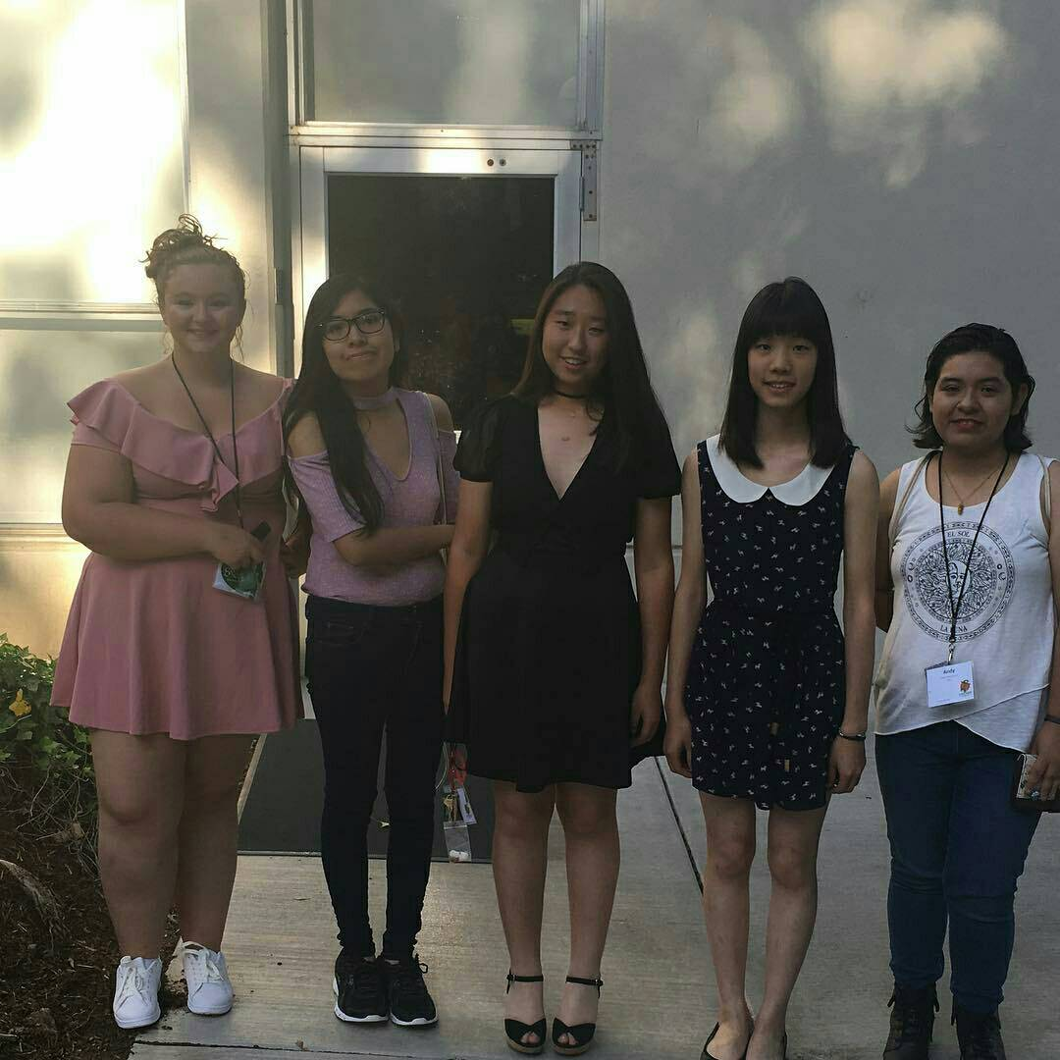
I took pictures with Russian and American delegates before the party.

