Visiting the CEI conference 2017 at Oregon
By Pearl Chen 陳悅敏
July 28, 2017
Stella Maris Ursuline High School 天主教花蓮海星中學
When I was a child, I really wanted to travel to America. Various cultures and lots of modern cities attract me to explore this wonderful place! In order to attend the CEI conference this year, I made much effort to protect our environment and visit the Oregon CEI to promote our ideas. We are concerned about the decrease of the local Mola mola population so we investigate how to maintain the local fishing business while preserving local ecosystem. To start this project, it is essential to know the number of captured Mola mola by interviewing the owners of local restaurants. However, we had been rejected for so many times because they had no interest for collaborations. Although it was a big challenge, we never give up! We made much effort for exploring our project and try to do our best.
In my oral presentation, I was very nervous on the stage, because this is my first English speech toward the audience from all over the world. I thought that I did not do very well at this very first moment. Then the second report was held in the afternoon, I treasured this opportunity to try my best. My impression is that I was pushing myself to the limit. I cannot do it well by just preparing and acting it as a show time. Since I was not confident with my presentation, anything unexpected would drive me crazy. During our preparation, I realized that team work is an important and valuable way to do the project. Sometimes we did our work individually. However, if we can do it together, we will not only work more efficiently but we also have more fruitful results.
In the section of presentation, I noticed that global warming is a big problem to our living environment at this age. What we can do is to treasure the resources and use them in an eco-friendly way. I was impressed by the Danish group. They found a way to transform ice into water for household supplies because the whole country is covered by ice. More amazingly, the Indonesian team only has one member and he did the entire project by himself. He developed a method to generate electric power by planting a plant. We really need creative and effective ways to minimize pollutions to our earth. This is why so many people from different countries join the Caretakers of Environment International. We can learn from each other and understand the environmental issues from other countries. We all know that saving the Earth is not just the responsibility of individual caretakers but it is the duty of all mankind. Unfortunately, some people do not care about that. We would like to stimulate people to concern more about our Earth pollution problems.
During the conference, I met a lot of people from different countries. By joining the CEI camping activities, I had made so many friends and learned about their cultures. On one day, we had a marketplace where each team from different countries shared their unique foods or specific games. In the following dancing party, we enjoy the enthusiasm of all dancers and cultural dancing dresses. I really love it! When we talked to each other in English, we not only improve our English pronunciations but also broaden our vision.
The first day in Oregon was a comfortable sunny day and it was not too hot. Sometimes it was cold in the morning when I walking on campus. The mornings here are like the winter time in Taiwan, but the weather would change easily so it is warm at noon. I really like the campus here. There is a large green field in the campus. When you lay there and look into the sky with a gentle breathing, all the vexation would disappear. It is a little weird, but I love that feeling! At night, we look into the sky where is full of stars which are more bright and clear than the stars I see in my country. For the comfortable weather, we went to some places to taste the awesome part in Oregon during these days. Mt. Hood, which mankind can find the balance to coexist with Nature forever. Unexpectedly, I saw a spectacular view of the mountain tops. It seems that those mountains are trapped by the surrounding cloud. How beautiful! Also, I am very impressive that we had met the Independence Day in America, which is on July 4th. That is an unforgettable event to me. We had a chance to participate in the festival and watched the fireworks. I will never forget the bright and lively shows.
I am so glad that the conference was held in Oregon. This place had given me lots of memories. It is a peaceful, graceful, and brilliant site. CEI conference is an international program which also allows us to make friends with each other all over the world. I appreciate that the organizers put a lot of effort, time, energy, and etc., into these 7 days activities. For instance, we visited many people, who are working very hard to save our planet. I had learned a lot in those visits. Though it had just last for a short period of time, I enjoyed every moment in the camp. Before I went to this conference, I was a bashful person and lost my social confidence. By attending the camp, I became more confident to talk to strangers. Although we have cultural barriers in our conversation occasionally, our friendship does not make any difference and we still keep us in touch with each other until now. We shared our life experiences and gave suggestions to solve the problem by someone else. All activities and games perfect my English speaking. The most important thing we did in this conference is to promote our own projects to other countries. I realized that the problem of each country is very critical. If we do not respond to it at once, more serious consequences will follow. It has changed my view to the world, reminding me not wasting natural resources. I will do my best to protect the Earth. Without a doubt, it is our duty to save the earth because we are living on it.
Our project is thinking a various way to protect Mola mola. We had many good ideas in the beginning, but sometimes we ignore the factors that may bring so many problems to us and polluted the earth. When I have different opinions with my partner, we always discussed with each other and found the best way to deal with the problems. By listening to others’ presentation, I have learned that the different point of view to the similar themes can solve the problem more completely. Next time if I have a chance to attend this conference again, I will try to complete our projects in the full spectrum. In this meeting, I looked up those speakers presenting with confidence and boldness. Although I was not born to speak to the crowed, I believe I could perform better on the stage if I keep practicing. Hopefully I could gain even more knowledge and have more interactions with other participants next year! From now on, I am truly a care taker and will motivate people to be care takers too.

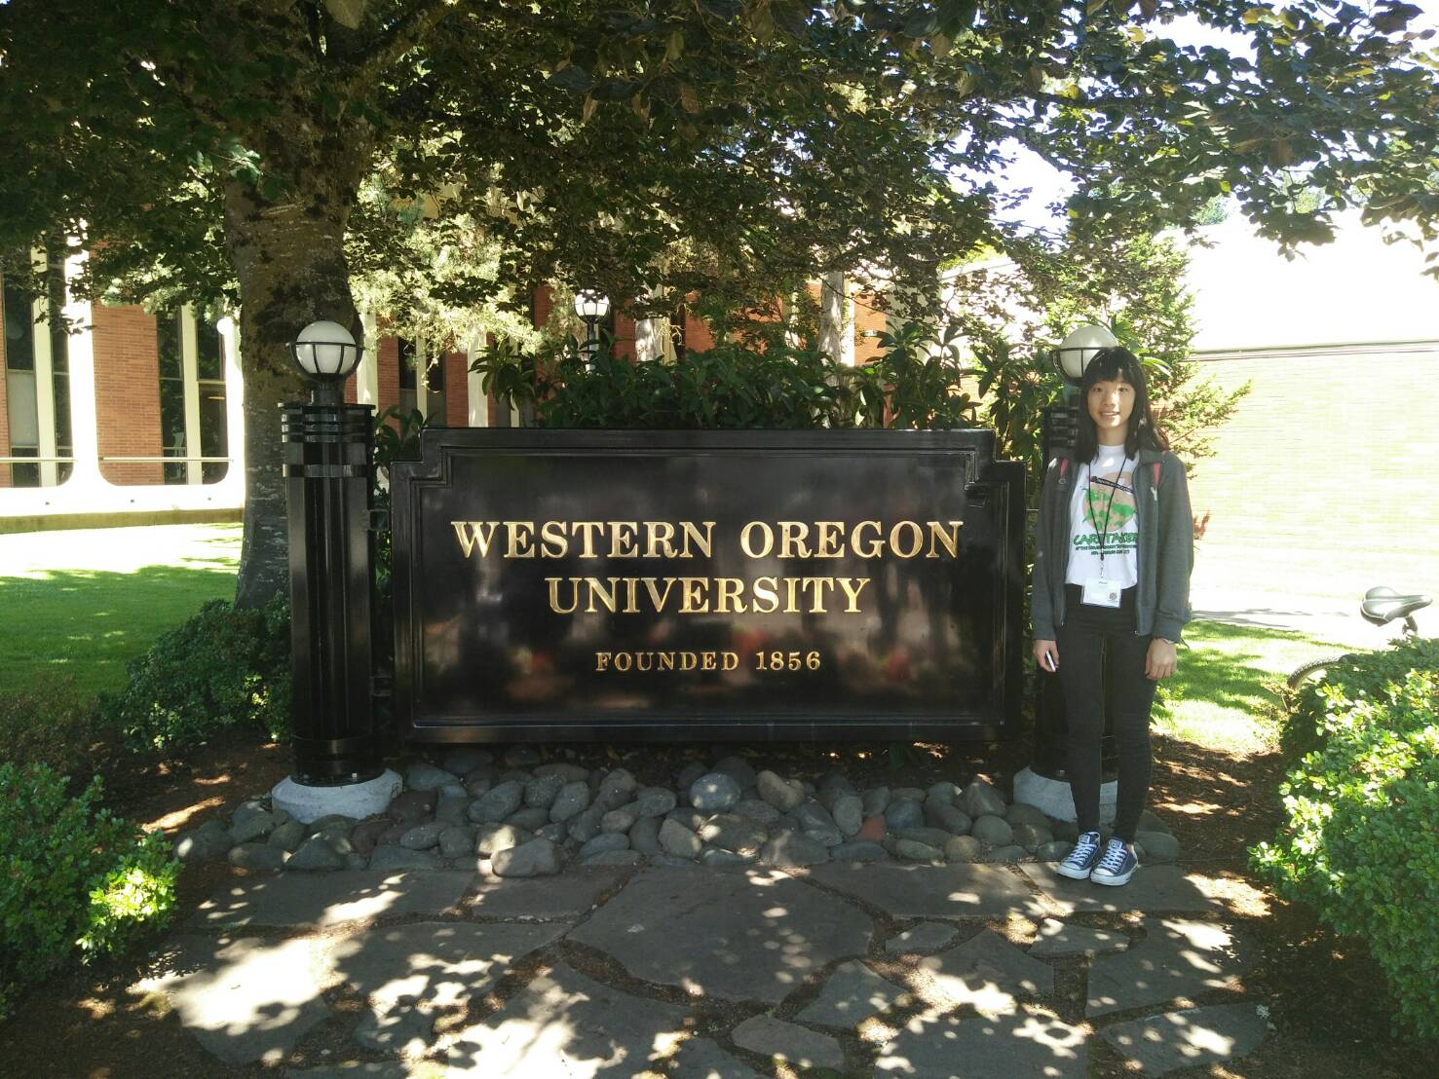
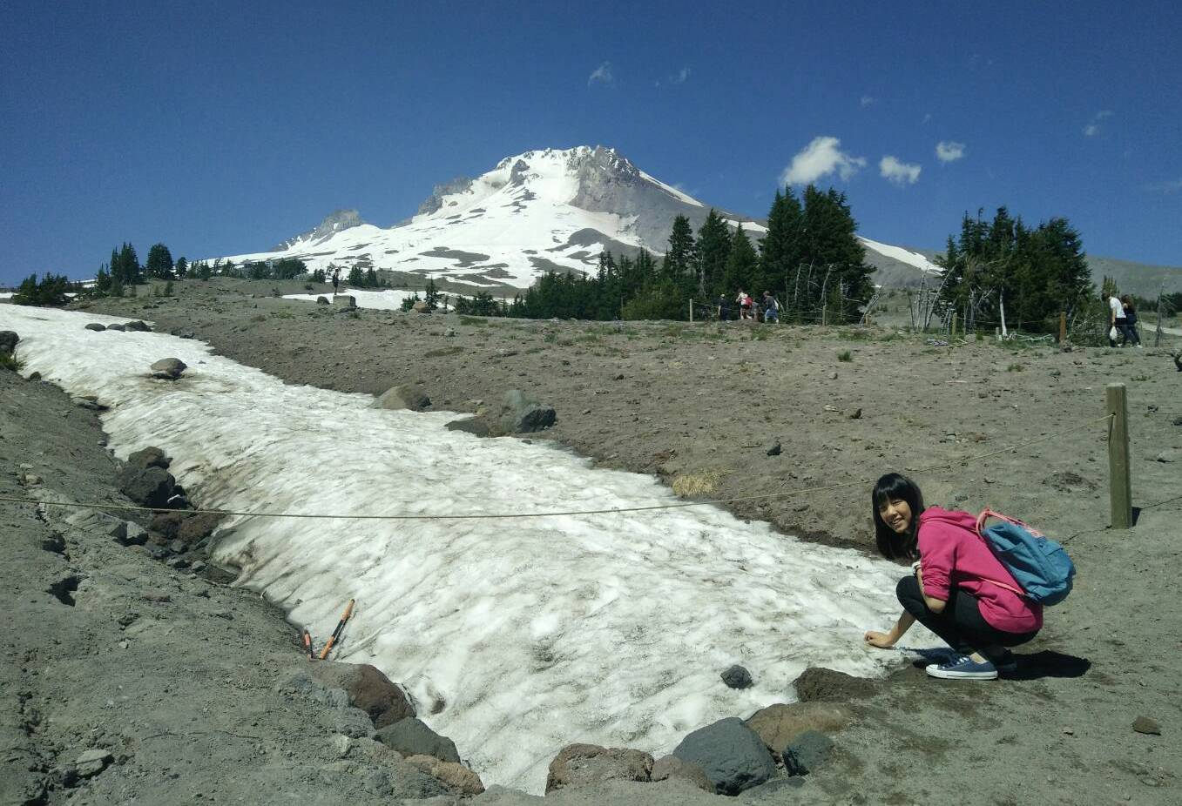

We went to Mt. Hood to enjoy the beautiful snow and the attractive scenery.

This is the university logo. We have a conference here for one week.

